A. Rates of reaction: Practical methods and calculating rates of reaction
- State two ways of finding the rate of reaction.
- State two units of rate of reaction. (HT: state 3)
- State two ways of measuring the quantity of reactant or product.
- A student carries out an experiment reacting hydrochloric acid (HCl) with calcium carbonate (CaCO3) to give calcium chloride (CaCl2) carbon dioxide and water. Write the balanced symbol equation for this reaction.

- The student collects 50 cm3 of carbon dioxide gas in 10 seconds. What is the rate of reaction? Include the units.

- (HT only) The student repeats the experiment again, this time they find the mass of the carbon dioxide collected. They collect 11 g of carbon dioxide in 10 seconds. Calculate the rate of reaction in mol/s.

- (HT only) What mass of carbon dioxide are they collecting per second if the rate of reaction is 0.075 mol/s?

B. Rates of reaction: Collision theory; effects of temperature, concentration, surface area and pressure on rates of reaction
- What is meant by the term ‘collision theory’?

- What happens to the gradient of a line if the rate of reaction is increased?

- According to collision theory, chemical reactions can only occur when…

- Other than concentration give three factors that affect the rate of reaction.

- Draw a labelled graph to show how changing any one of these factors may affect the rate of reaction. Include the line before and after the change.

- The graph below shows how the reaction is affected when the concentration of hydrochloric acid is doubled when reacting with excess magnesium. Explain why the amount of hydrogen gas doubles and why the rate of reaction doubles; use collision theory in your response.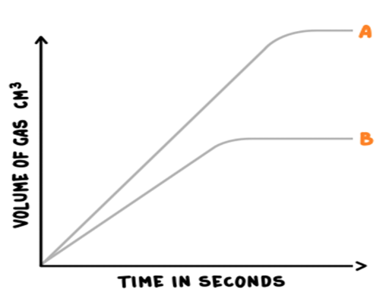
C. Rates of reaction: Catalysts
- What is a catalyst?
- What is a biological catalyst?
- Name a process which makes use of biological catalysts.
- How does a catalyst alter the rate of reaction?
- A student carried out three reactions to investigate how quickly oxygen gas was given off by decomposing hydrogen peroxide.
2H₂O₂ O₂ + 2H₂O
Each time she changed the chemical she was adding to see if it was a catalyst.
Here are her results.
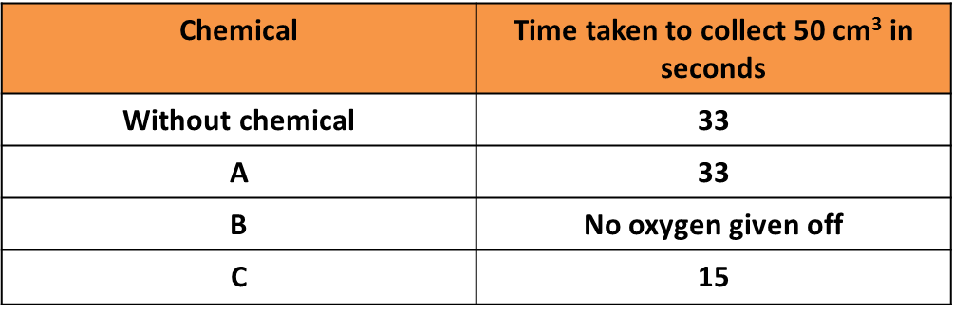
Which chemical was a catalyst? Explain your answer.
- Draw the reaction profile for 2H₂O₂ O₂ + 2H₂O with and without a catalyst and label the activation energies.
D. Energy changes: exothermic and endothermic reactions
- Why is the amount of energy in the universe at the end of a chemical reaction the same as before the reaction takes place?

- What is an exothermic reaction?

- Give an example of an exothermic reaction.
- What is an endothermic reaction?
- Give an example of an endothermic reaction.
- Give an everyday use of endothermic reactions.
- How would you know if an exothermic reaction had occurred?
- How would you know if an endothermic reaction had occurred?
- Below is a table of results for four reactions, the temperatures before and after the reactions are also given.
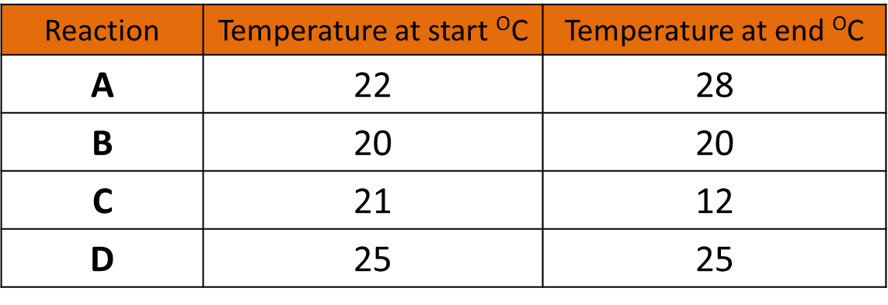
- Which reaction is endothermic? Explain how you know this.

- Which reaction is exothermic? Explain how you know this.

E. Energy changes: Overall heat energy change for a reaction and calculating energy change
- During a chemical reaction energy is needed to…
- In a chemical reaction energy is released when…
- What are bond energies used to calculate?
- How do you calculate the overall energy change of a reaction?
- Is bond making exothermic or endothermic? Why?
- Is bond breaking exothermic or endothermic? Why?
- (HT) The bond energy between a hydrogen and a nitrogen atom is 386 kJ/mol, the bond energy between two hydrogen atoms is 432 kJ/mol and the bond energy between two nitrogen atoms is 942kJ/mol. Using these bond energies, calculate the overall energy change for the following reaction.

2NH₃ N₂ + 3H₂

- (HT) Is the reaction exothermic or endothermic? Explain your answer.

F. Activation energy and reaction profiles
- What needs to happen for a reaction to take place?
- What is meant by the term activation energy?
- What can a reaction profile be used to show?
- What is an exothermic reaction?
- What is an endothermic reaction?
- On the reaction profile below what is shown by the letters?
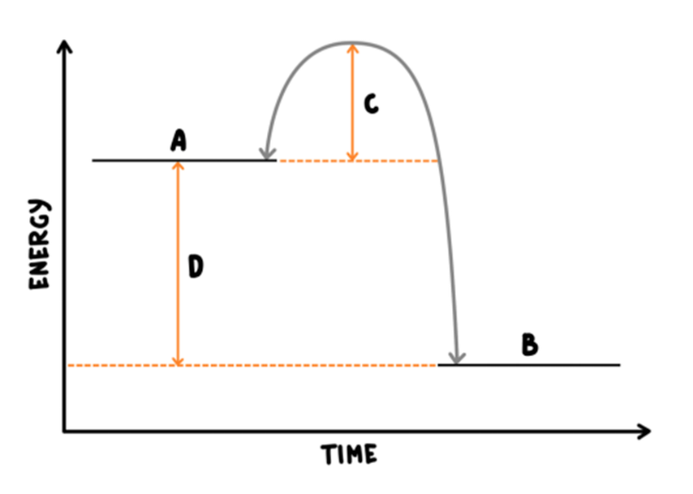
A
B
C
D

